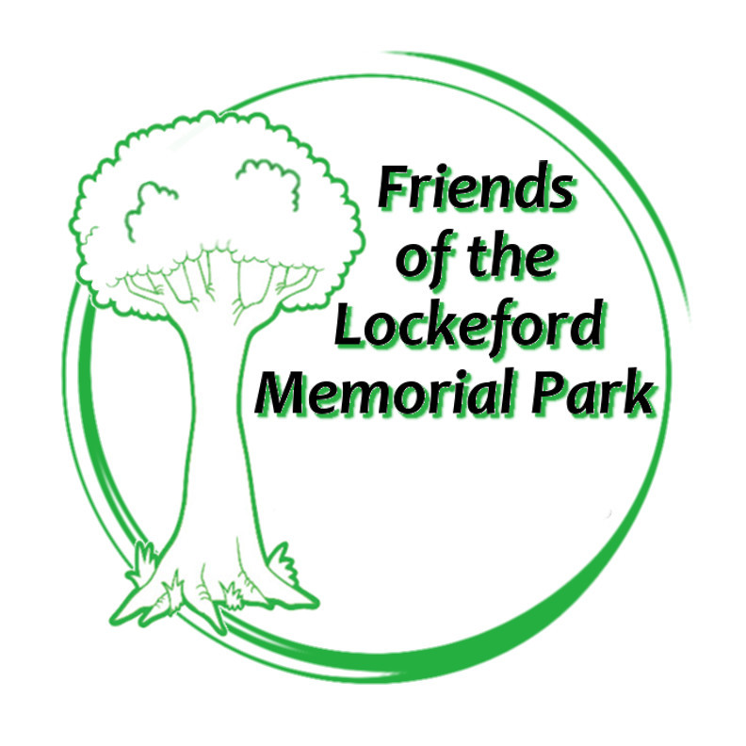
www.lockefordpark.org

Membership Application

The purpose of the Friends is to provide support and assistance to the Lockeford Community Services District for the community park, recreation programs, equipment and the community center.

Date: ___________________

Name ____________________________________________________________

Address __________________________________________________________

_________________________________________________________________

Contact phone _____________________________________________________

Email ____________________________________________________________

Annual membership is $15 per person

Would you be interesting in participating in: (check all that apply) fundraising__

events__ website__ graphics__ social media__ public outreach__ donations__

grants__ other__________________________________________________________

Mail completed form and payment to:
Friends of the Lockeford Memorial Park
P.O. Box 1703 Lockeford, CA 95237 or Email to: lockefordpark@gmail.com

A nonprofit public benefit 501(c) (3) organization
Donations are tax deductible to the extent allowable by federal law
Fed tax ID # 47-4383811

